**Outside Exhibitors**

**ANNOUNCEMENT OF THE JOINT MEETING OF THE INTERNATIONAL PRIMATOLOGICAL SOCIETY AND THE MALAGASY PRIMATOLOGICAL SOCIETY**

**AUGUST 10-15, 2025**

**ANTANANARIVO, MADAGASCAR**

The International Primatological Society in conjunction with the Malagasy Primatological Society will meet from August 10-15, 2025. in Antananarivo, Madagascar. All scientific and social sessions will take place at the CCI Ivato Conference Center. Complete conference information is available at the Congress website (www.ipsmadagascar.org). Registration will begin online on December 1, 2024 and will continue through the conference. All congress activities will be held at CCI Ivato.

IPS is a multidisciplinary association of approximately 1200 professionals and students whose work is focused on nonhuman primates. In the last two decades, the biennial IPS Congresses have attracted between 650 and 1600 registrants (there were 1500 for the 2016 Congress in Chicago, and 850 for the 2018 Congress in Nairobi, and 700 in Kuching, Malaysia in 2023). IPS members include veterinarians, geneticists, psychologists, physicians, neuroscientists, anthropologists, zoologists, conservation biologists, ethologists, zoo professionals, technical personnel, and field assistants; primarily from universities, NGOs, zoological parks, field stations, sanctuaries, and research facilities throughout the world. Both captive and field scientists are active members of this society, so there is great interest in data acquisition and analysis equipment and programs; tracking, navigation, and recording equipment; sanctuaries; databases; conservation efforts and organizations; research and biomedical instrumentation; books, journals and other information resources; captive enrichment devices, caging, diets, etc.

It is our hope that you will contribute to the success of the IPS Meeting by exhibiting materials from your organization. Exhibitors will be assigned space in the same areas as the posters, Silent Auction, Photo Contest, and refreshment stations. Attendees will be free to examine the exhibits at their leisure from Monday morning through Friday afternoon. Exhibitors will be acknowledged in the Congress program.

If you are interested in exhibiting materials at our Congress, please fill out the exhibitor’s reservation form (enclosed) and upload it to our conference registration site (IPS profile page) along with the appropriate fee, by July 1, 2025. If you have additional questions about the meeting, either now or at any time before the meeting takes place, please feel free to contact me. Finally, if you are unable to exhibit materials at our Congress, but wish to offer support for IPS, we ask that you to consider sponsoring the online streaming of the Congress or making a donation to our organization. Sponsors and donors will be specially recognized in the meeting program.

**EXHIBITOR INFORMATION**

**IN PERSON EXHIBITIONS**

**Exhibitor’s Fees** A **6’** skirted table with power outlet, pamphlet stand, and two chairs for five days (Sunday evening through Friday afternoon) is **$1600.00 ($1300.00** for nonprofit organizations). **The exhibitor fee includes complimentary registration to the Congress for** **one attendee.** The exhibitors’ space will be on the path to the meeting rooms and the registration area, and will be contained within the large space that will also contain the poster sessions, Silent Auction, Photo Contest, and refreshments. Sale and exhibition of merchandise will be allowed only within the designated area and only by individuals registered to exhibit at the Congress.

**Registration Fees** Each exhibit includes one complimentary registration for the Congress, allowing the exhibitor to attend the opening reception, all coffee and tea breaks, evening receptions, all scientific sessions and the closing banquet. Any additional exhibitors must register separately for the Congress. Registration details can be found at the IPS Congress registration website (https://ipsmadagascar.org/the-congress/registration/). Registration fees may be partially refundable in extreme circumstances, but refunds will not take place until after the Congress.

**Included with your exhibitor’s fees**The number of skirted tables you request and two chairs per table  
Wireless internet access (complimentary)  
A pamphlet holder per table

A power outlet per table

**One complimentary registration for the Meeting per table**General assistance with exhibit storage and setup

**If you will not require any of these items, please let me know and we may be able to negotiate a discount.**

**Equipment rental** If you need any additional equipment, please contact me for rental information. To guarantee that the equipment you want to rent is available, contact me before July 1, 2025. Please note that some requests may be expensive to satisfy.

**Set-up** You may set up your display on August 9, 2025 beginning at 1 PM. Displays must be completely dismantled by 3 PM on Friday, August 15, 2025. Exhibits may be visited from 9 AM – 8 PM each full day (including evening poster sessions); the exhibit area will be secure, but we recommend the removal of any computer equipment and valuables each night.

**Shipping/storage** The mode of shipment of exhibit materials is the sole responsibility of the exhibitor. Instructions for shipping your exhibit materials will be forthcoming.

**Taxes and fees** If you plan to sell merchandise at the meeting, you will need to comply with all local licensing laws and taxes. It is your responsibility to check with the office of the Comptroller of Public Accounts to determine how to comply with these laws.

**Accommodations** See the Accommodation Information that is included in the meeting information on the IPS Congress website (www.ipsmadagascar.org) to plan your accommodations.

**NON-ATTENDING / ONLINE EXHIBITORS**

If you are not able to attend to the in-person meeting, you could still exhibit information about your organization with banners or videos that will be published in the online streaming platform. We invite you to consider the following packages for sponsoring the online streaming of the IPS Congress.

|  | Vulnerable primates Sponsor  US$ 600 fee | Endangered primates Sponsor  US$ 1000 fee |
| --- | --- | --- |
| Organization’s banner displayed in the platform at the beginning of each congress journey | 5 days | 5 days |
| Organization’s banner displayed in the platform at the beginning of congress sessions | 12 sessions | All sessions (25 sessions) |
| Organization’s video displayed in the platform at the beginning of congress sessions | 12 sessions | All sessions (25 sessions) |
| Organization’s logo displayed in the main page of the congress website https://iipsquito.com | No | Yes |
| Shared table space for display of brochures, journals or books 1 | No | Yes |
| Organization’s name displayed in a list of Sponsors acknowledgements in the IPS website [Home (internationalprimatologicalsociety.org)](http://www.internationalprimatologicalsociety.org/) | Yes | Yes |
| Organization’s name mentioned in the introductory talks at the beginning of each congress journey | Yes | Yes |

1 A shared table space for the display of brochures, journals, or books (20-book maximum), will be available for Endangered Primates Sponsors. The IPS Exhibits Committee in Quito will set up the display and monitor it on a regular, but not continuous, basis. Books, journals, or brochures will not be returned, but will be donated at the discretion of the IPS Exhibits Committee to the Student Prize Competition, the Silent Auction, and/or to the library of the host institution in Quito. Instructions for shipping the exhibit materials will be forthcoming.

**Exhibitor handout in conference bag**

The fee is $800 for the insertion of a maximum of two items (brochures, etc.) into the delegate’s bag that each participant in the Joint Meeting will receive. Materials to be inserted must be sent to the Congress address (c/o - IPS 2025 - GERP Madagascar - Lot II M 78 Bis Antsakaviro - Antananarivo 101 - Madagascar) at least 30 days prior to the Congress, so that the inserts can be added to the bags in advance.

**Special donations to support the IPS Congress** If you are unable to exhibit materials at our Congress, but wish to offer support for IPS, we ask that you consider a donation to our organization. Registered exhibitors may also wish to add a donation to their regular exhibitor fees. Donors will be specially recognized in the Congress program. Your support would be greatly appreciated.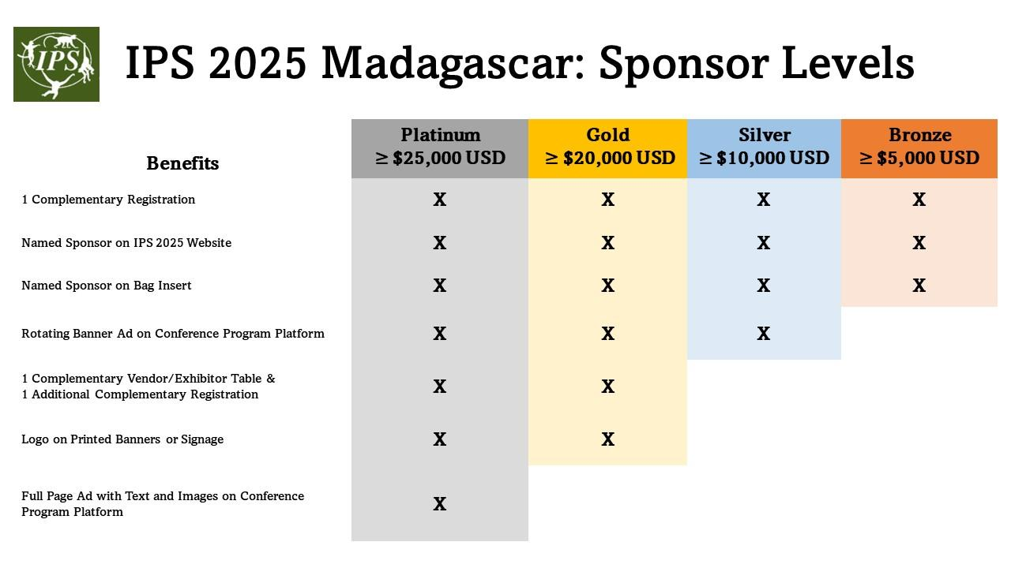

I look forward to hearing from you,

Trudy Turner, Ph.D.  
Treasurer and VP for Membership, International Primatological Society